SMTP Client

📬 What is an SMTP Client?
# Source: Chatgpt (GPT-5-Mini) at [1/21/2026]
An SMTP client is a software or tool that sends emails using the SMTP (Simple Mail Transfer Protocol). It connects to an SMTP server and delivers your email messages to it, which then forwards them to the recipient’s email server.

🧠 Think of it like this:
# Source: Chatgpt (GPT-5-Mini) at [1/21/2026]
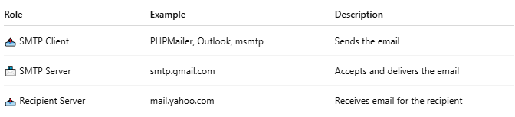

Role | Example | Description
📤 SMTP Client | PHPMailer, Outlook, msmtp | Sends the email
📨 SMTP Server | smtp.gmail.com | Accepts and delivers the email
📥 Recipient Server | mail.yahoo.com | Receives email for the recipient

✅ Examples of SMTP Clients
# Source: Chatgpt (GPT-5-Mini) at [1/21/2026]
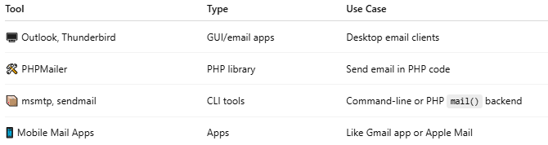

Tool | Type | Use Case
🖥️ Outlook, Thunderbird | GUI/email apps | Desktop email clients
🛠 PHPMailer | PHP library | Send email in PHP code
📦 msmtp, sendmail | CLI tools | Command-line or PHP mail() backend
📱 Mobile Mail Apps | Apps | Like Gmail app or Apple Mail

📡 What an SMTP client does:
# Source: Chatgpt (GPT-5-Mini) at [1/21/2026]
- Connects to an SMTP server (e.g., smtp.gmail.com)
- Authenticates (username/password or App Password)
- Sends the email headers, body, attachments
- The server accepts it and forwards to the recipient

🔒 Optional Features:
# Source: Chatgpt (GPT-5-Mini) at [1/21/2026]
- TLS/SSL encryption
- Authentication (SMTP AUTH)
- Queueing
- Retry logic

🔁 Example Flow with PHPMailer (SMTP client):
# Source: Chatgpt (GPT-5-Mini) at [1/21/2026]
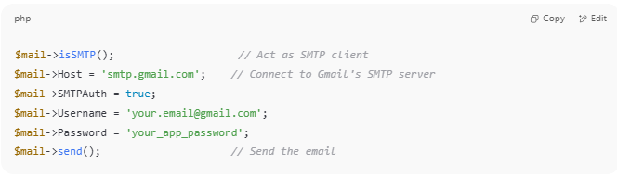

$mail->isSMTP(); // Act as SMTP client
$mail->Host = 'smtp.gmail.com'; // Connect to Gmail's SMTP server
$mail->SMTPAuth = true;
$mail->Username = 'your.email@gmail.com';
$mail->Password = 'your_app_password';
$mail->send(); // Send the email

🔧 Why use an SMTP client?
# Source: Chatgpt (GPT-5-Mini) at [1/21/2026]
- To send emails from apps, servers, or scripts
- To integrate email into your PHP, Python, or Node.js code
- To avoid running your own mail server

